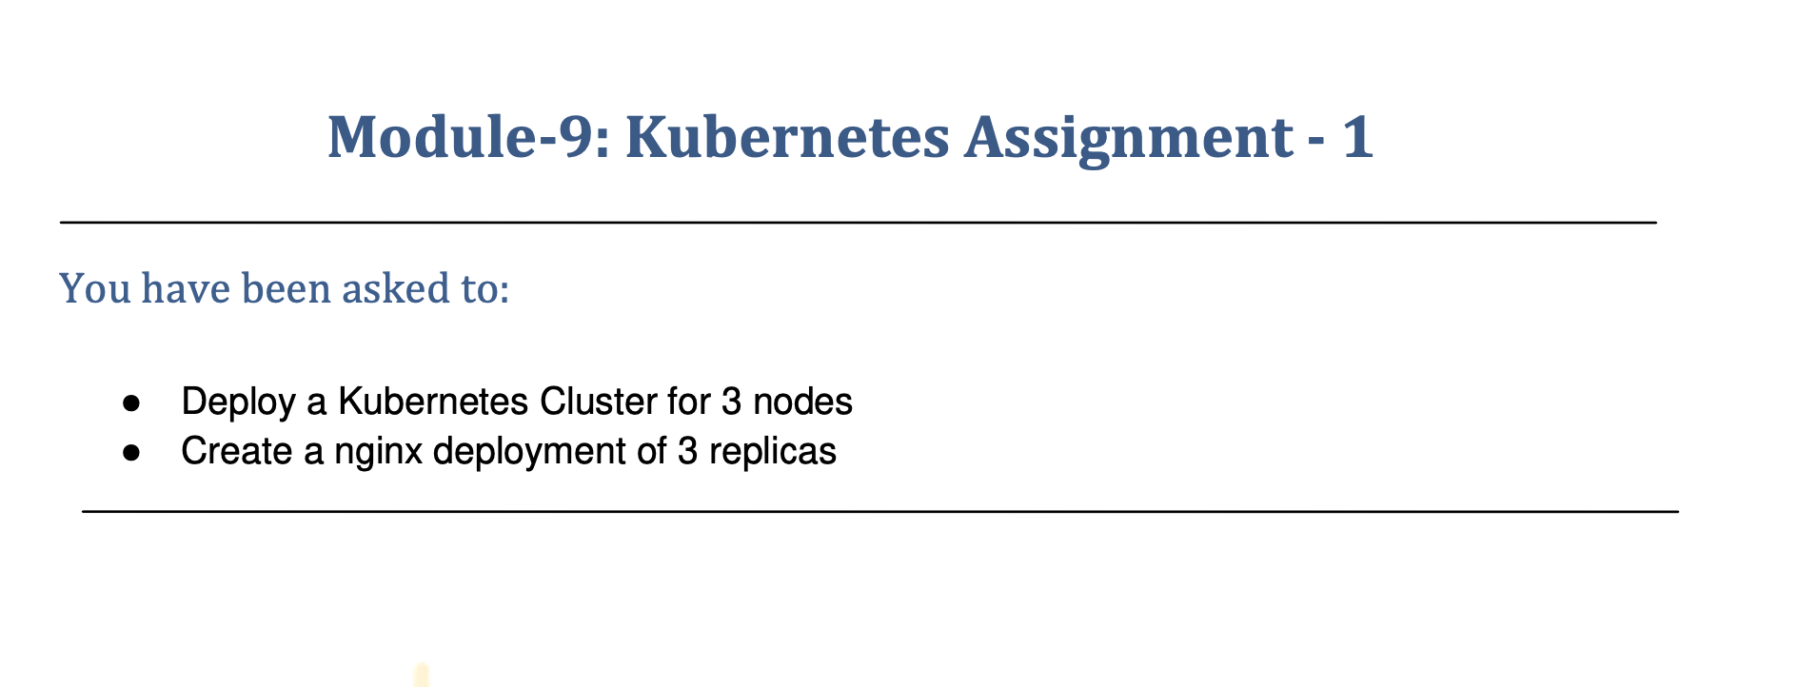

Go to AWS CONSOLE .

Launch t2.medium instance for Kubernetes master cluster and 2 slave t2.micro

Select default subnet

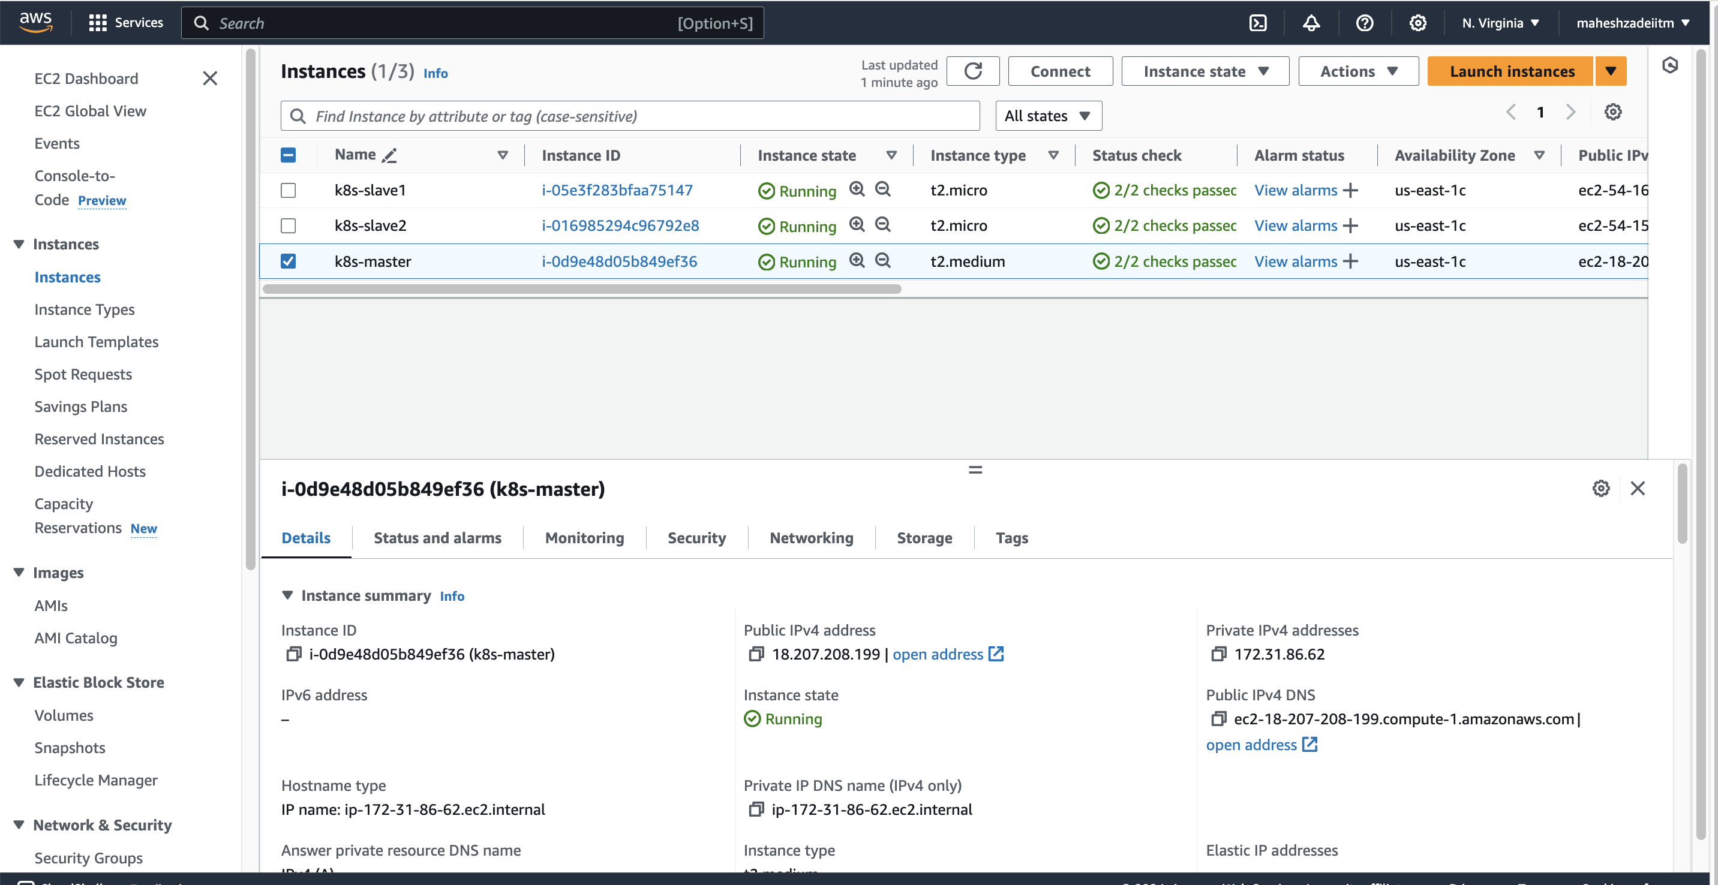

Update all the 3 EC2 Instances

By sudo apt update

Install docker on all 3 instances by the below script.

sudo wget https://raw.githubusercontent.com/lerndevops/labs/master/scripts/installDocker.sh -P /tmp

sudo chmod 755 /tmp/installDocker.sh

sudo bash /tmp/installDocker.sh

check docker by the command docker -v ( installaed in all 3 machines )

ubuntu@ip-172-31-94-196:~$ docker -v

Docker version 27.2.1, build 9e34c9b

Now connect master node all 2 slave node by below command

ubuntu@ip-172-31-86-62:~$ sudo docker swarm init

Swarm initialized: current node (x9kqyro56dsyuzzgtgtn6zdgj) is now a manager.

To add a worker to this swarm, run the following command:

docker swarm join --token SWMTKN-1-4yk5bn5kom4vmsxkf642pra97iutcn8piy6s9p8hmjnlmhvra7-34q1cy2zksk8vfh5ckjfzpyuh 172.31.86.62:2377

To add a manager to this swarm, run 'docker swarm join-token manager' and follow the instructions.

ubuntu@ip-172-31-86-62:~$

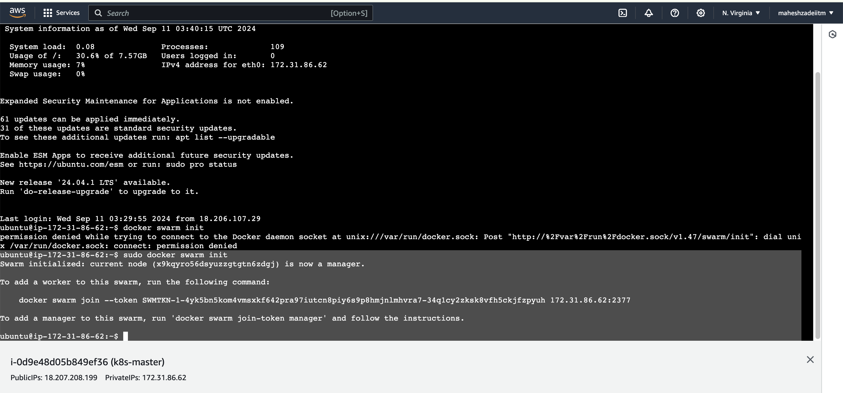

Now run the below command to join both slave nodes .

docker swarm join --token SWMTKN-1-4yk5bn5kom4vmsxkf642pra97iutcn8piy6s9p8hmjnlmhvra7-34q1cy2zksk8vfh5ckjfzpyuh 172.31.86.62:2377

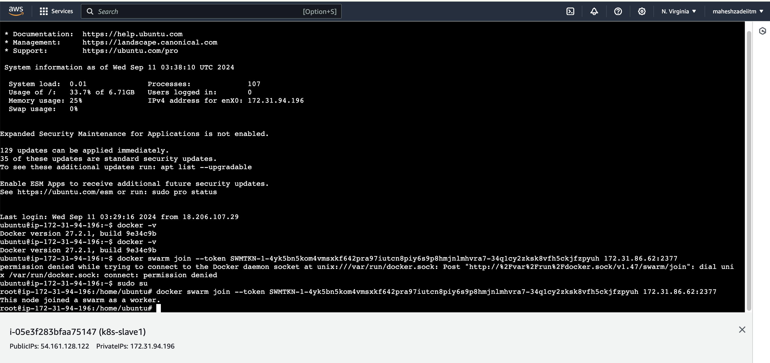

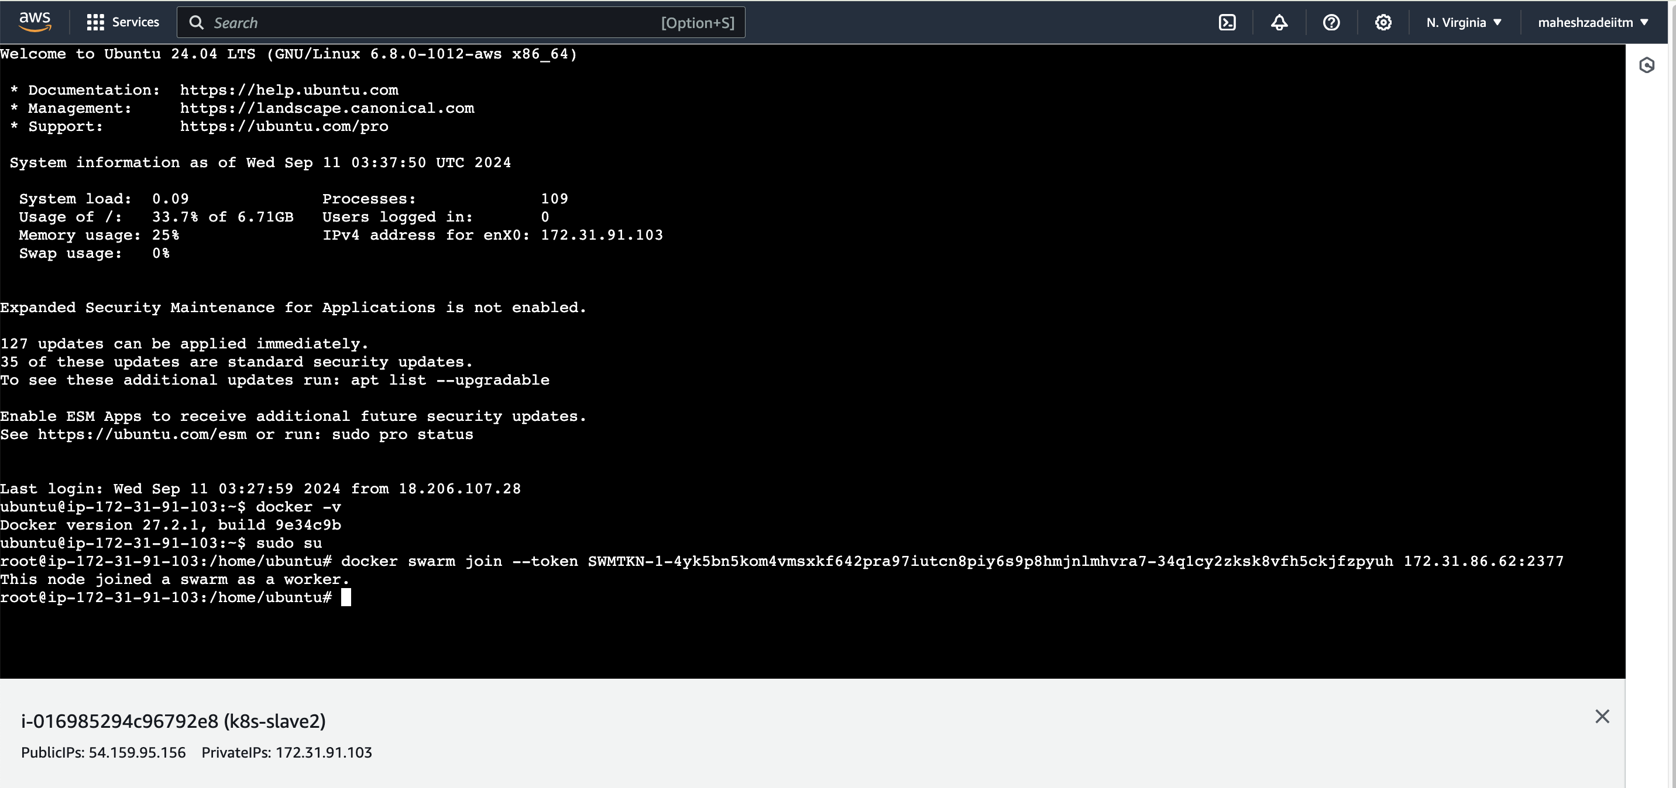

Now both the slave nodes are connected to master node

Now check swarm is active in all nodes

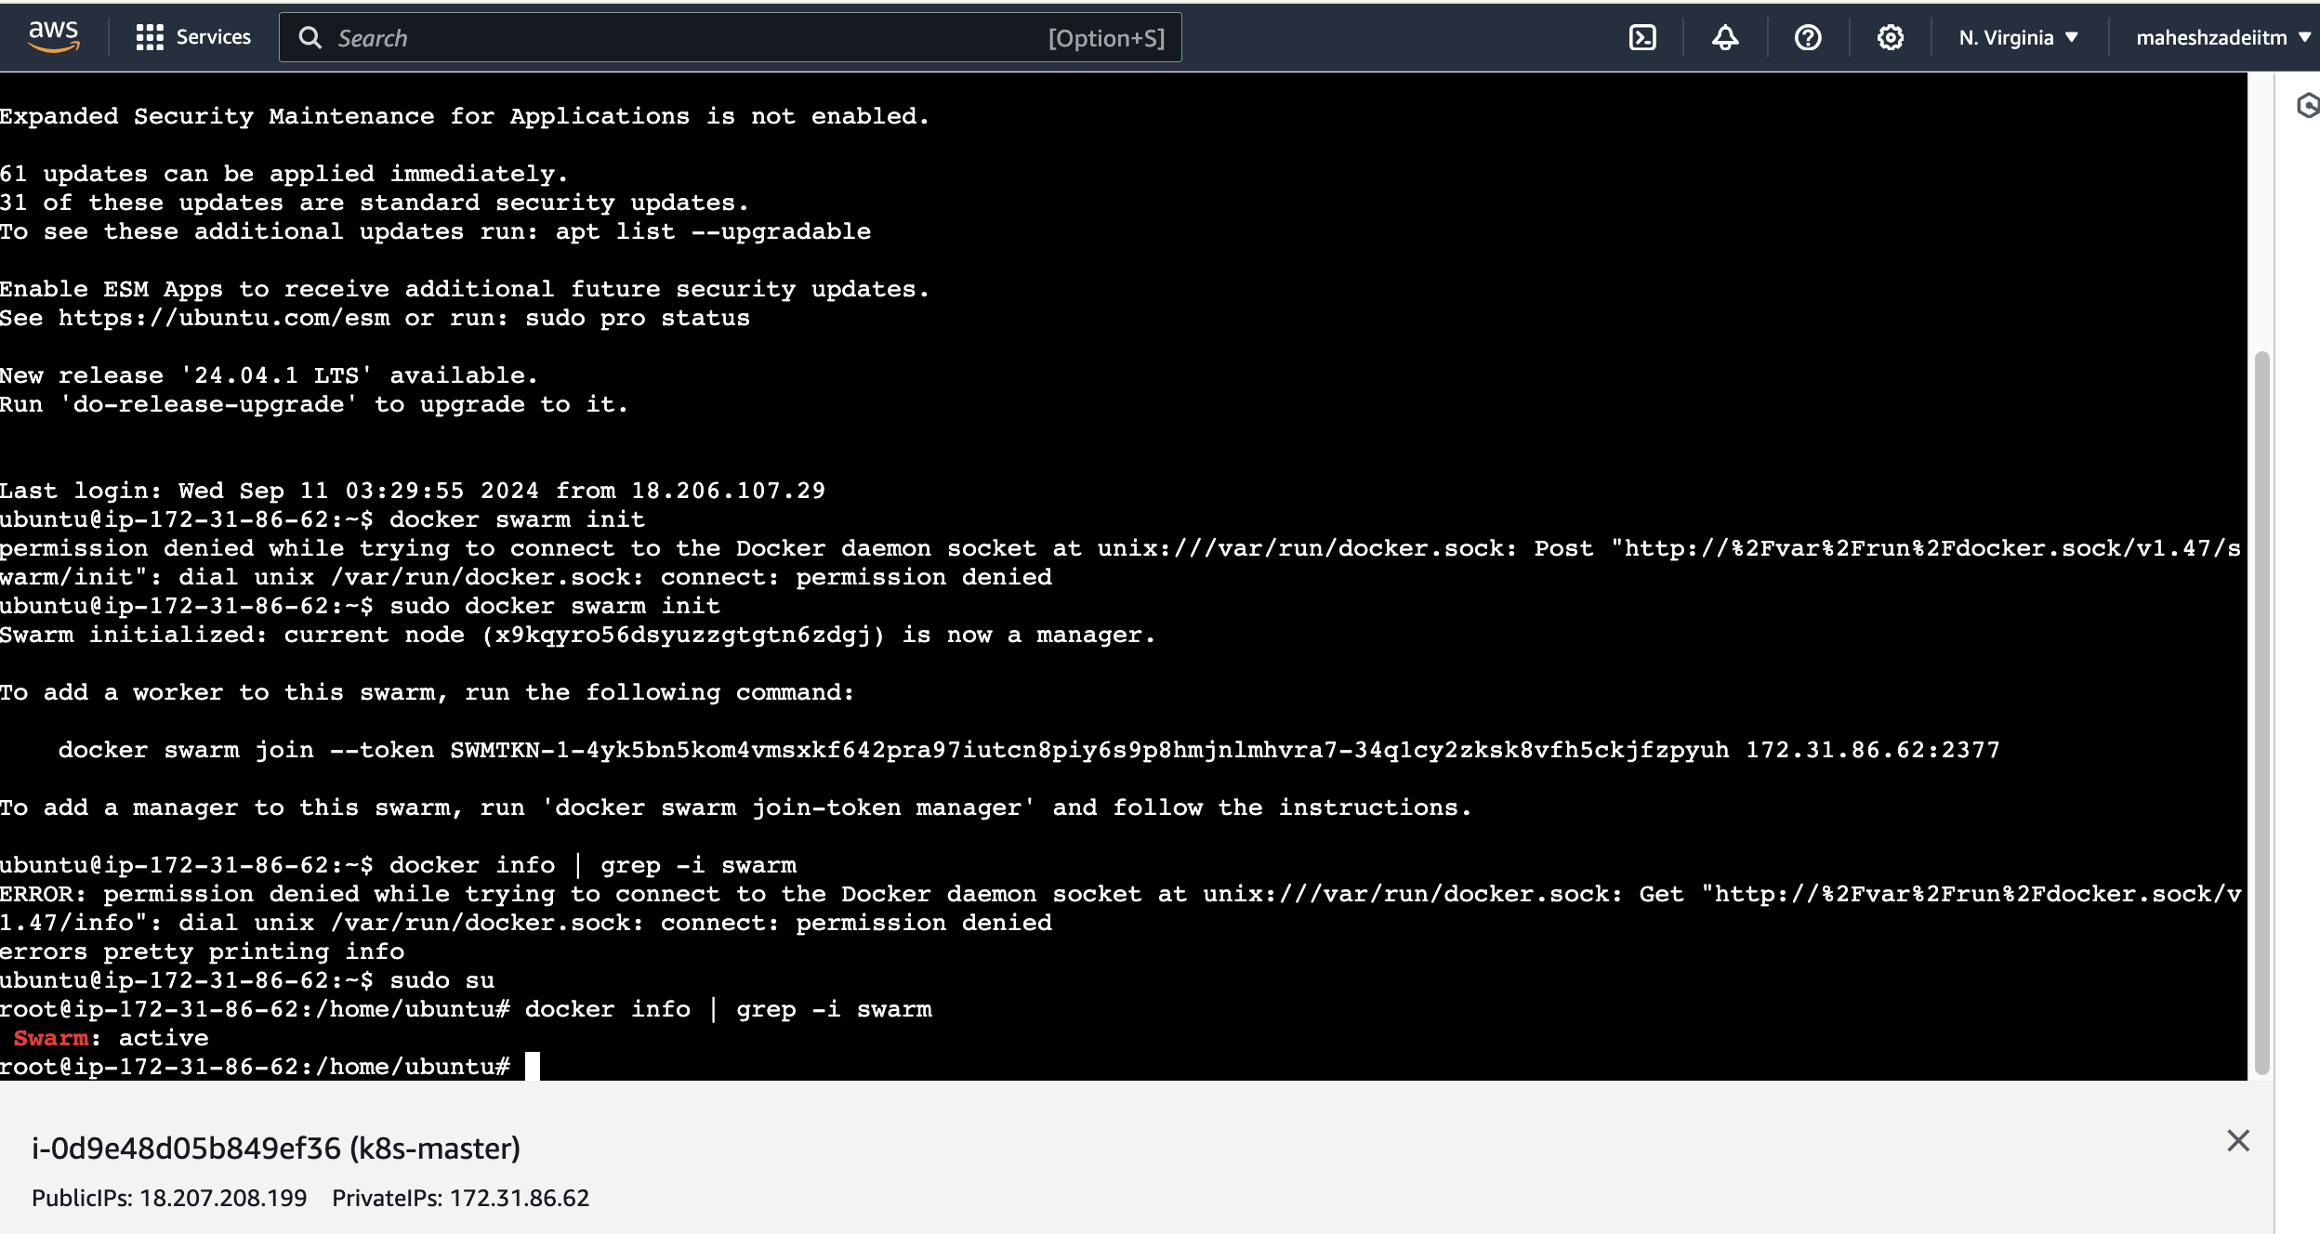

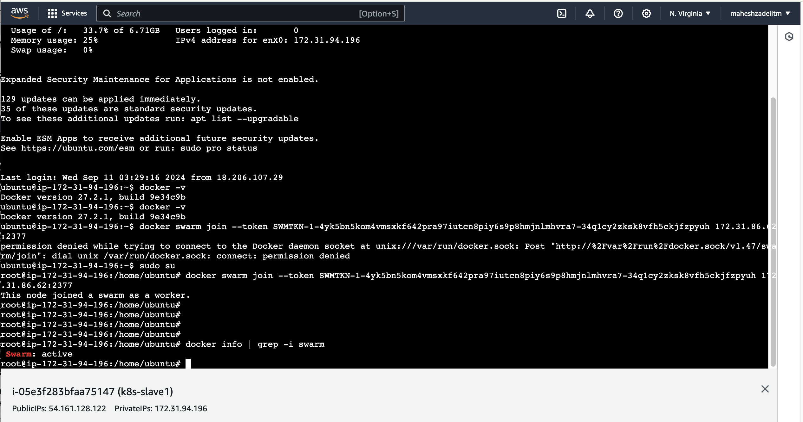

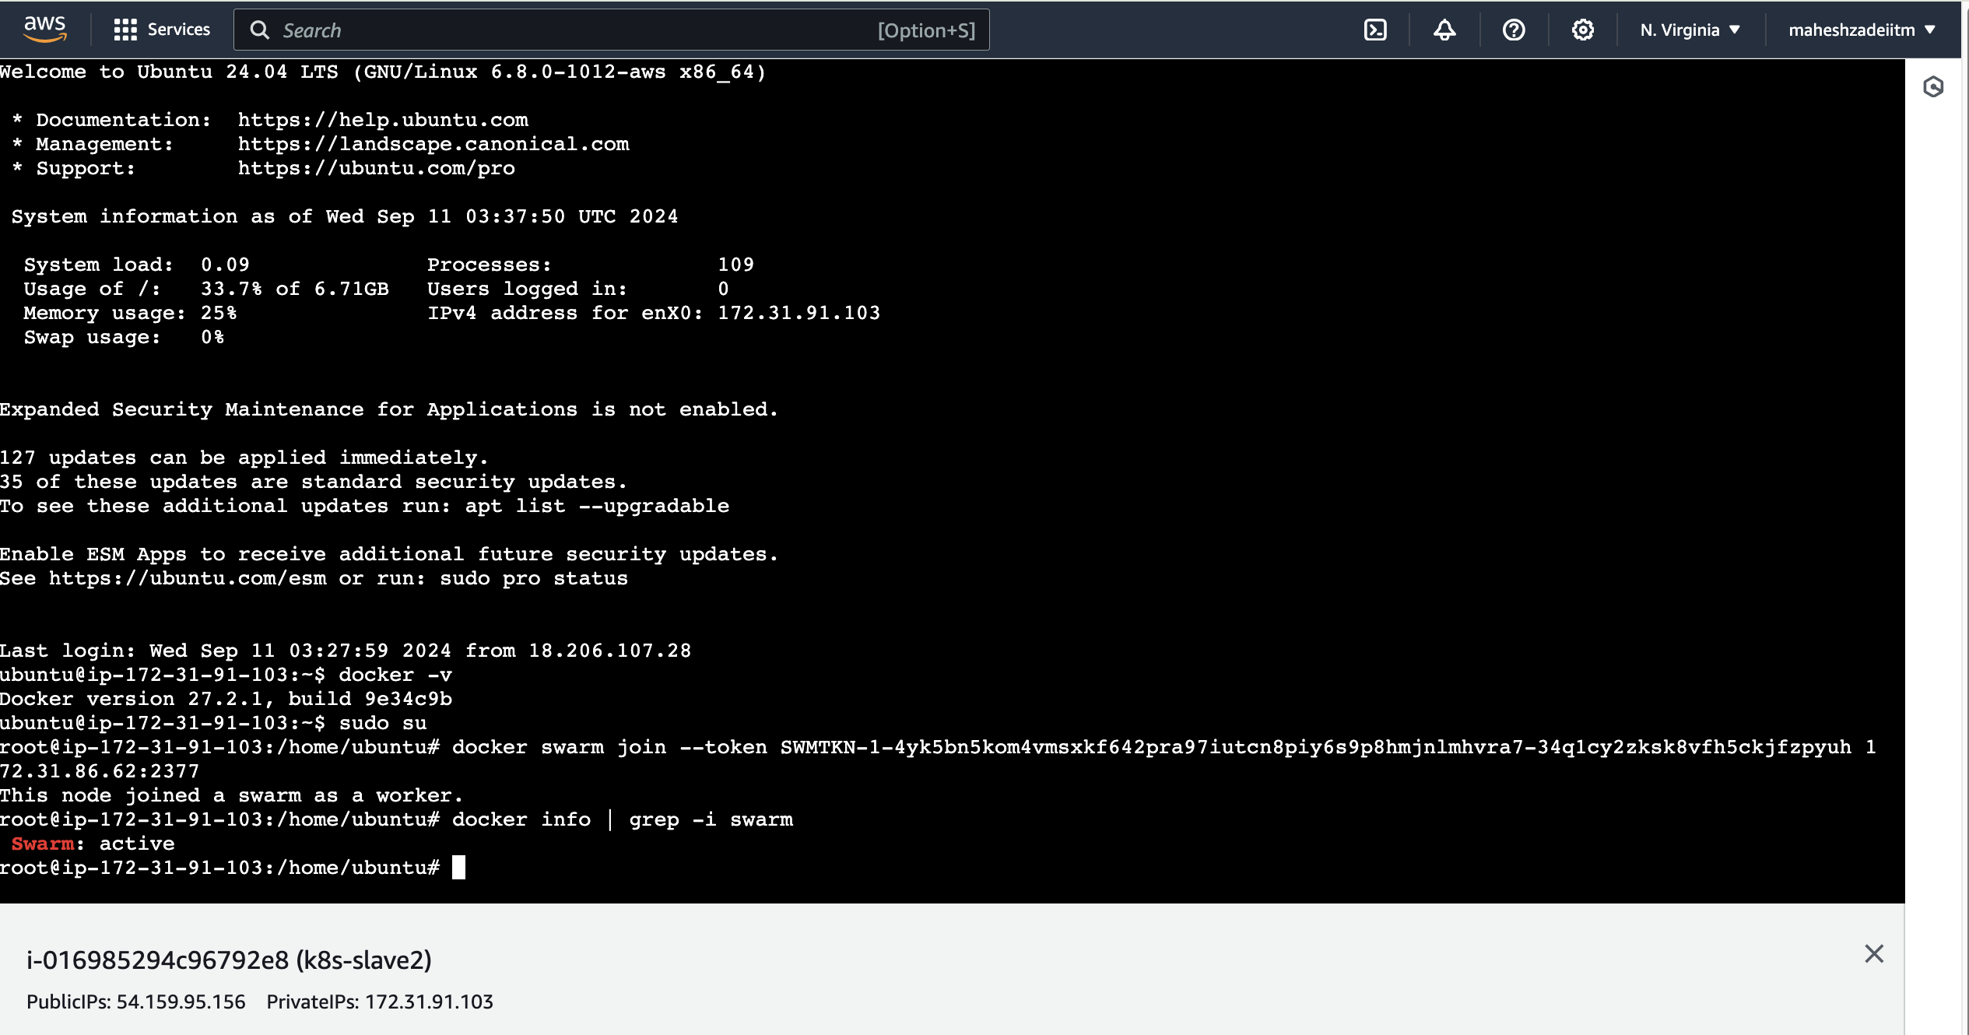

Pls check the leader node ( Manager status )

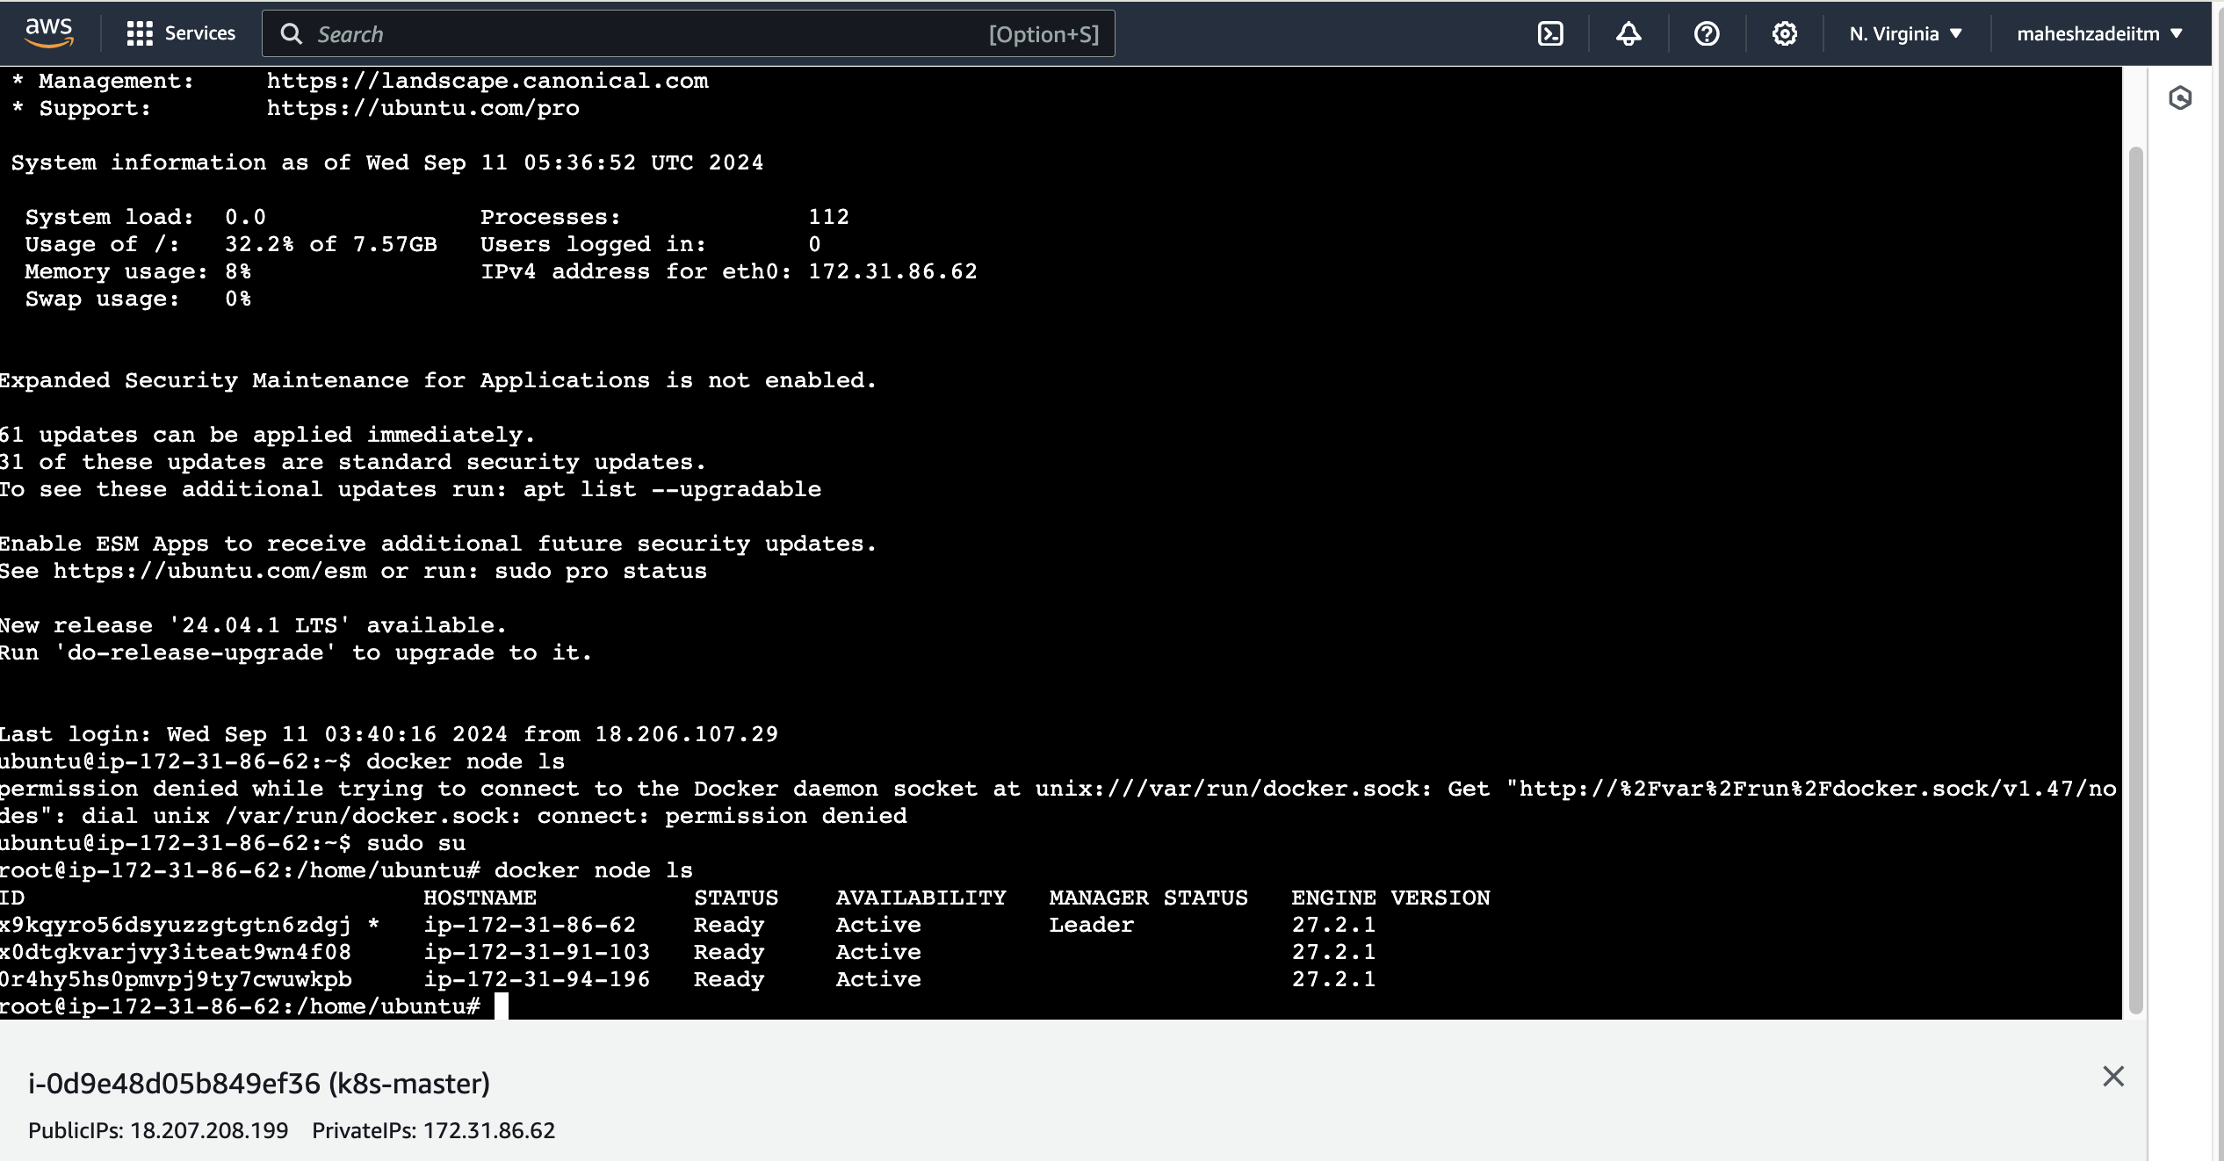

We just build a cluster

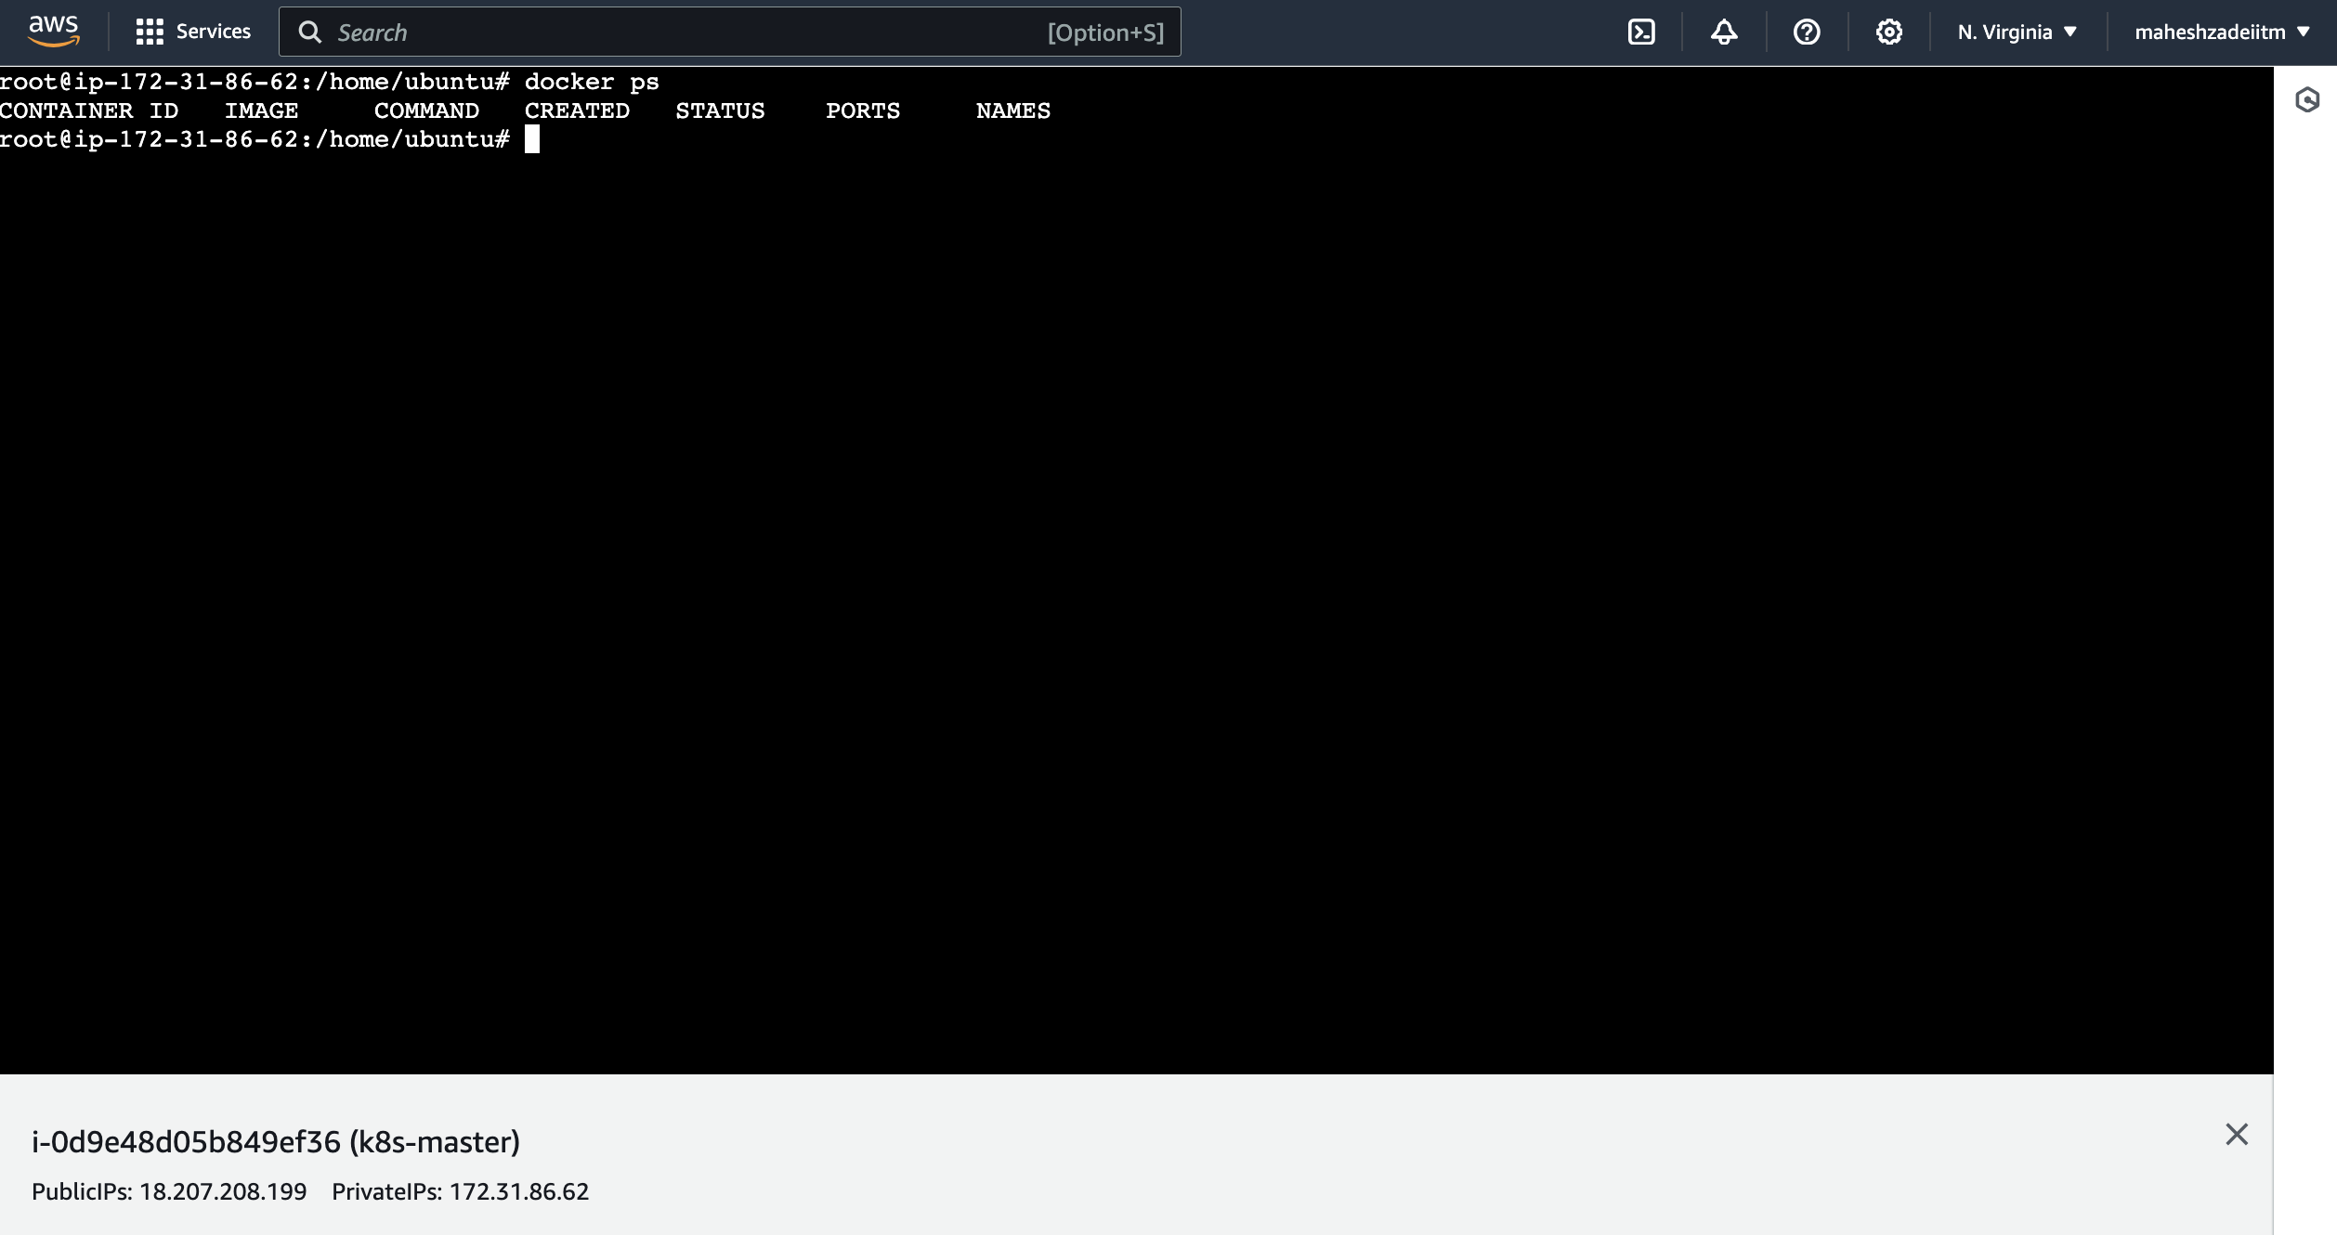

No container running of the all the three servers

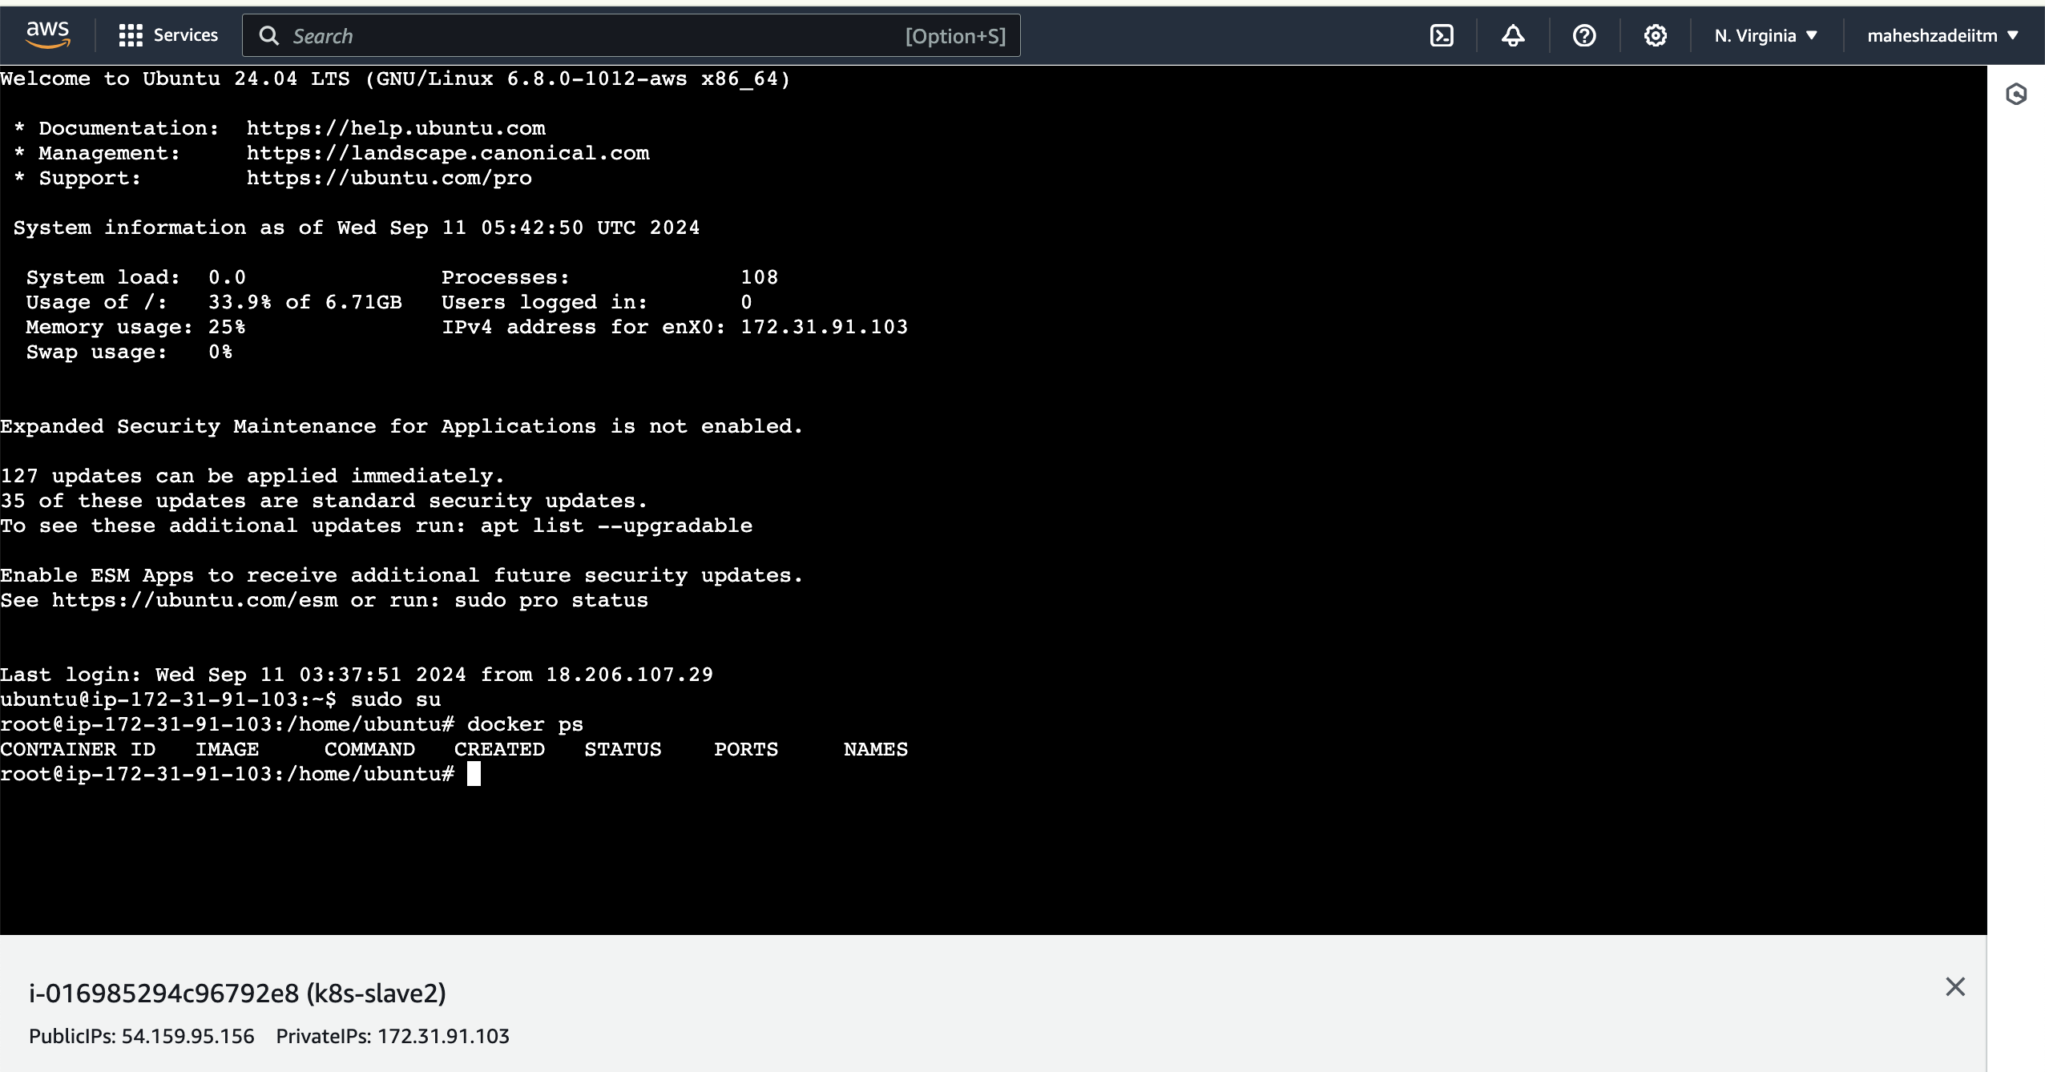

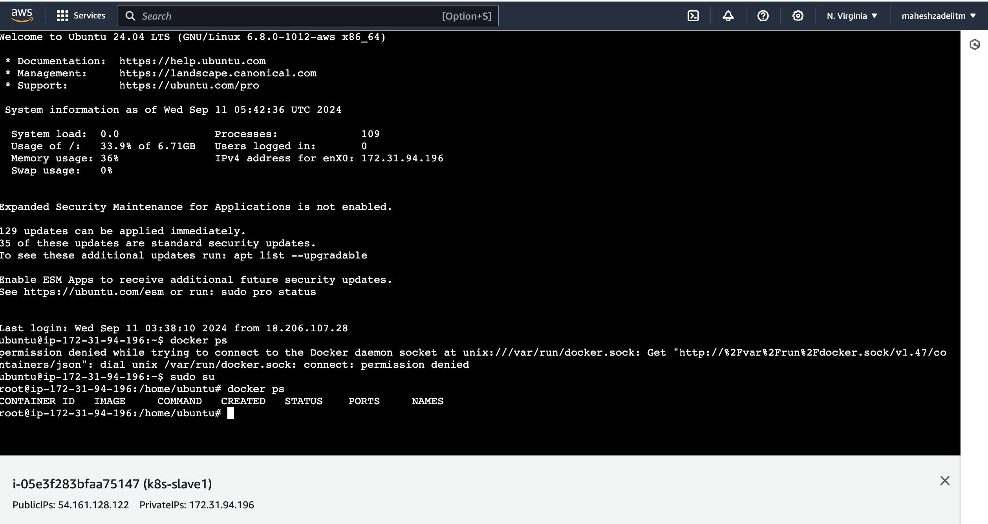

Now regenerate the tokens by below command

Run the command

docker swarm join-token worker ( token Generated )

oot@ip-172-31-86-62:/home/ubuntu# docker swarm join-token worker

To add a worker to this swarm, run the following command:

docker swarm join --token SWMTKN-1-4yk5bn5kom4vmsxkf642pra97iutcn8piy6s9p8hmjnlmhvra7-34q1cy2zksk8vfh5ckjfzpyuh 172.31.86.62:2377

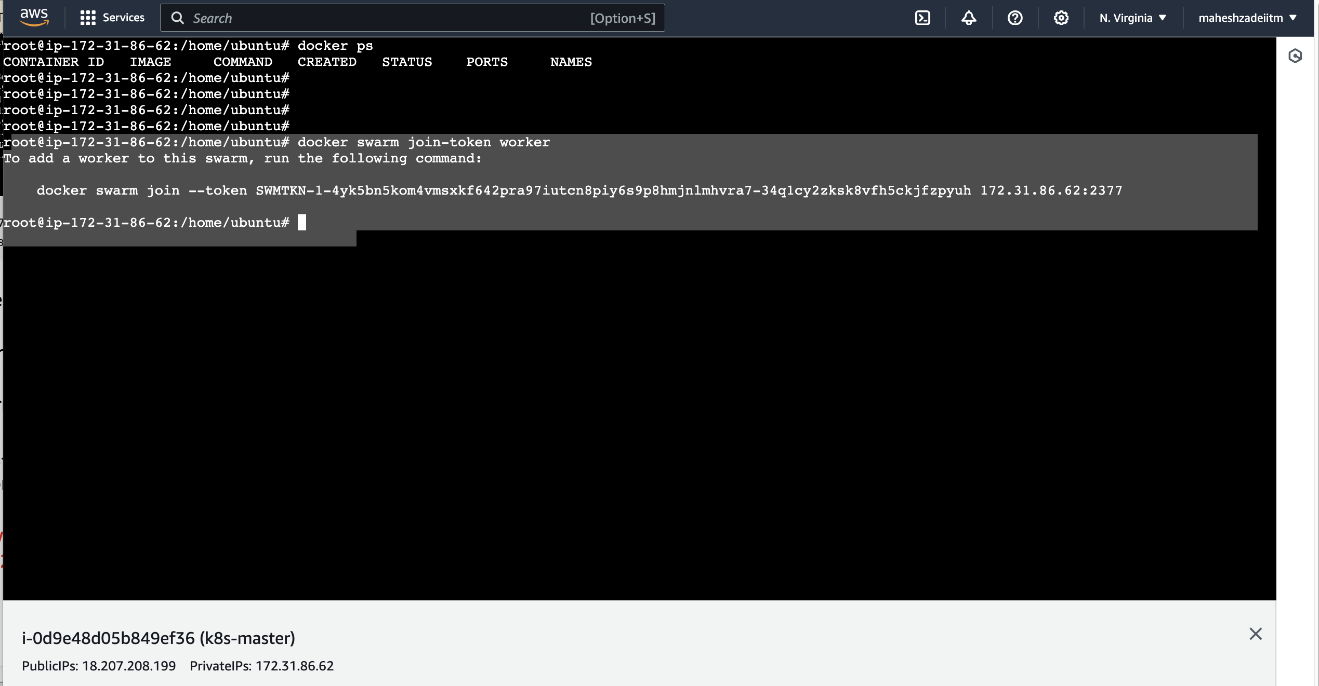

Joined worker nodes to master that is the idea

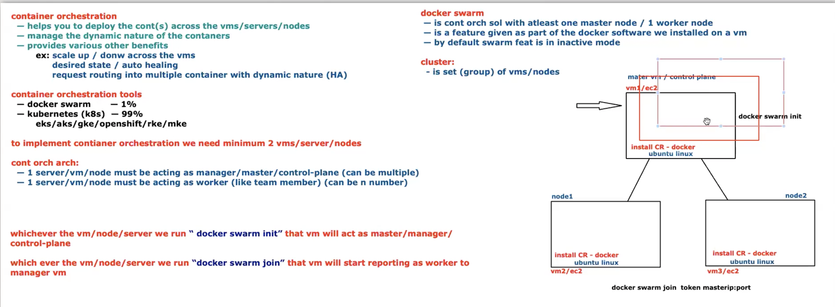

Now how to build amultiple containers

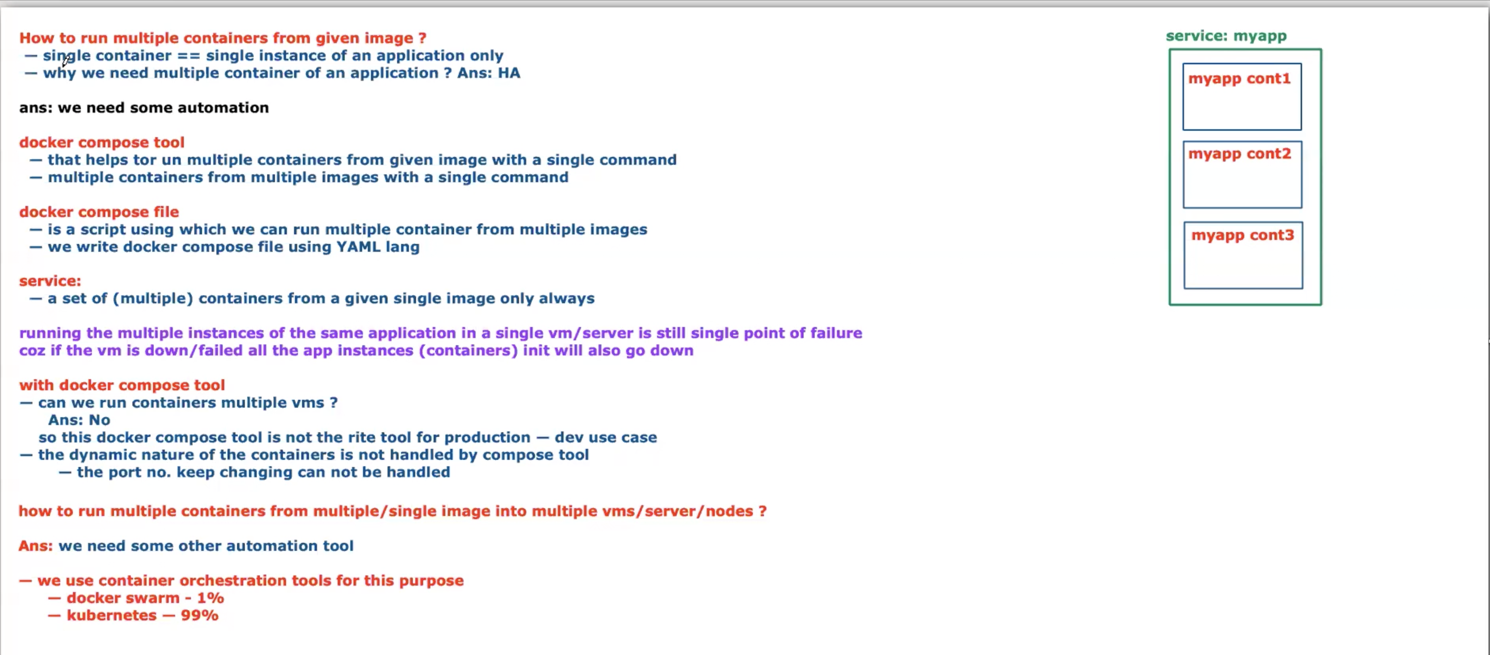

Service is a group of containers in a given image.

Now install Kubernetes so we have deactivate docker swarm in both the slave node

ubuntu@ip-172-31-91-103:~$ sudo su

root@ip-172-31-91-103:/home/ubuntu# docker swarm leave --force

Node left the swarm.

root@ip-172-31-94-196:/home/ubuntu# docker swarm leave --force

Node left the swarm.

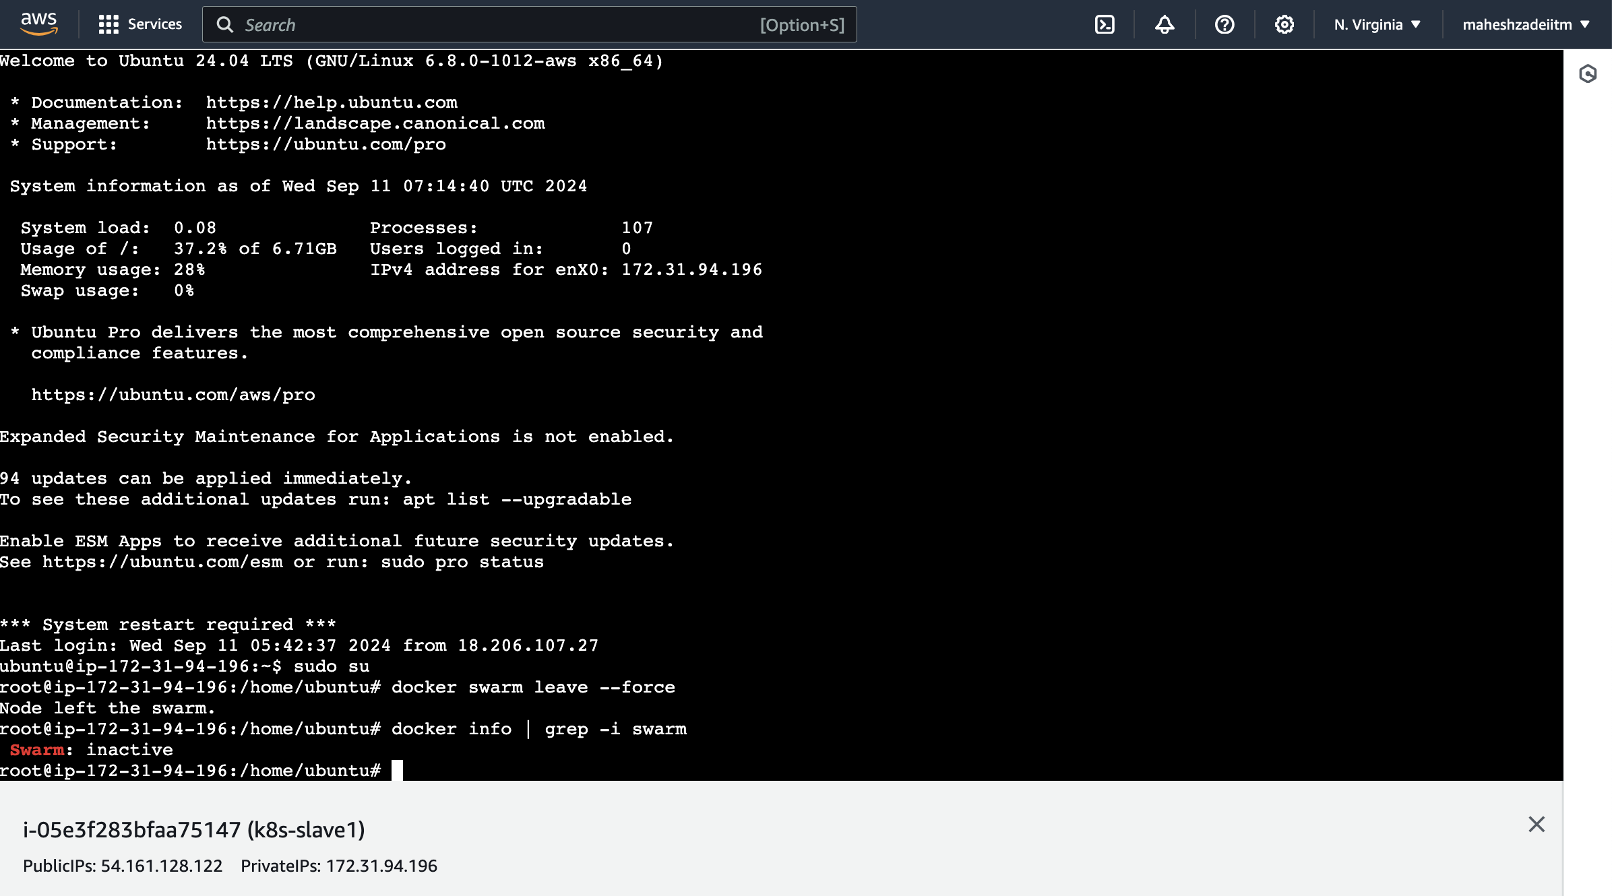

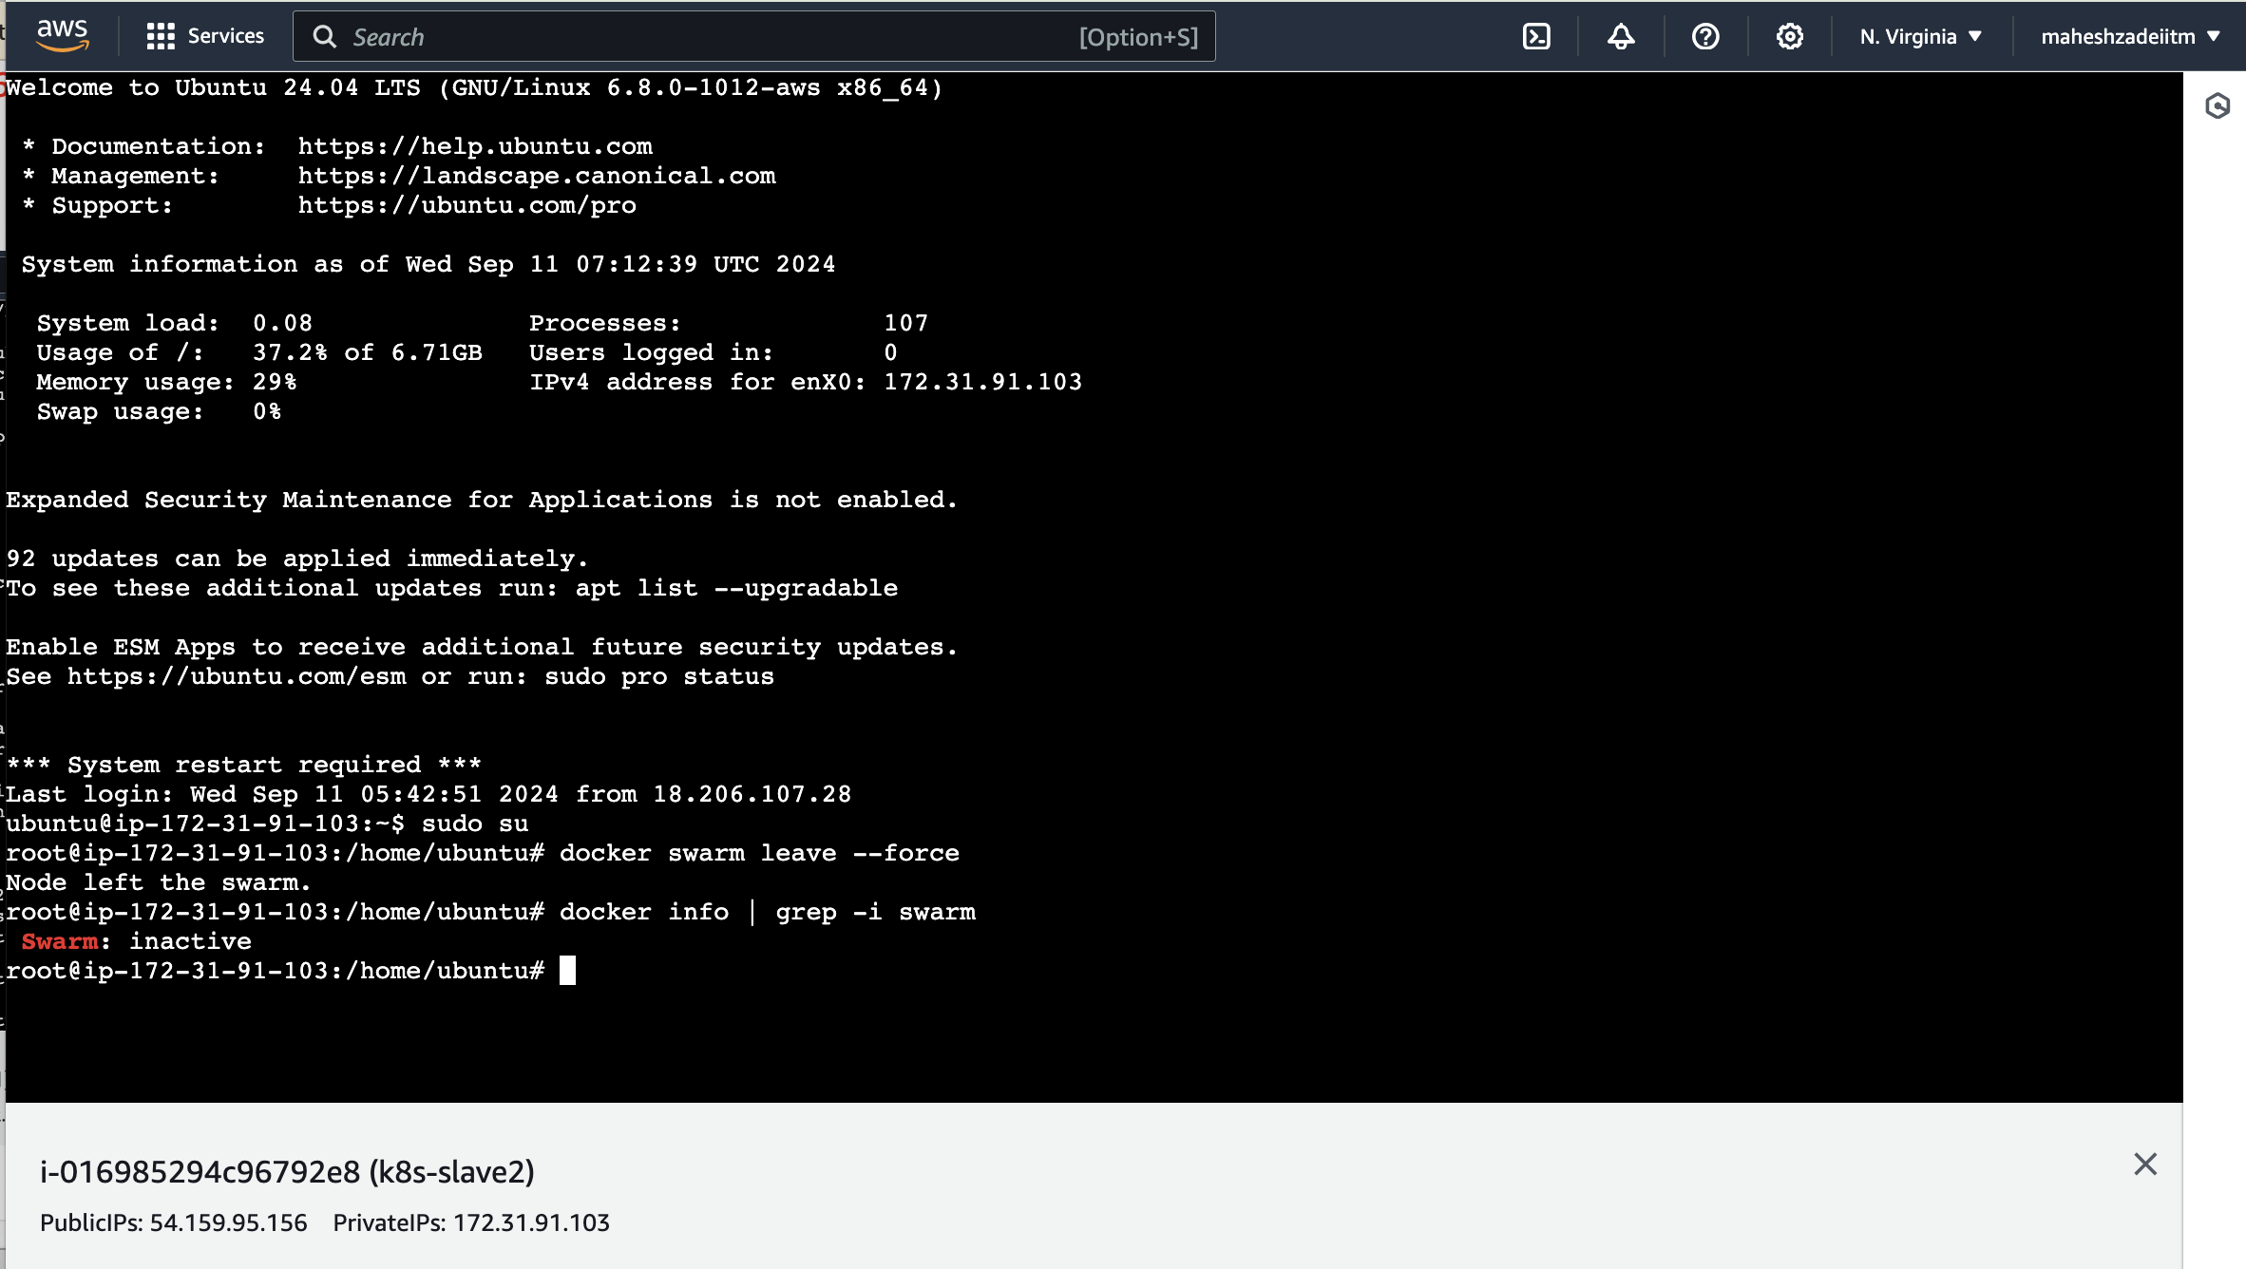

Deactivate in Master node as well ( docker swarm

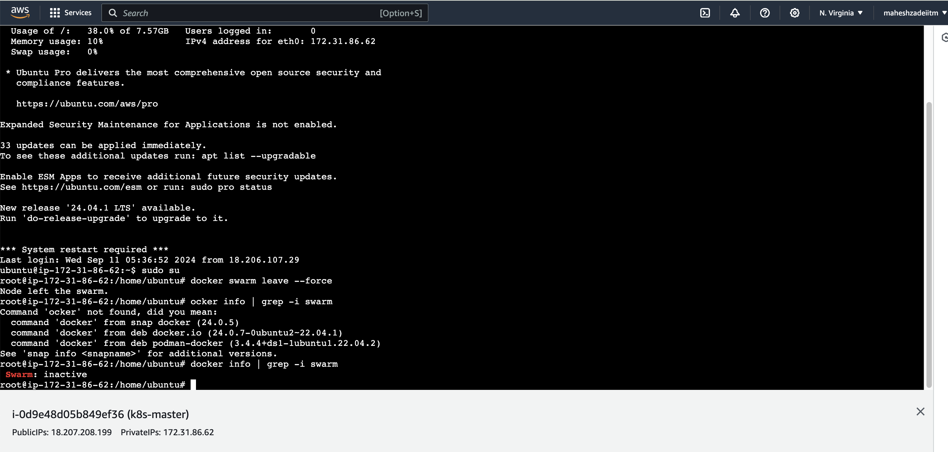

Primary feature of docker software

